## Topic of research: Existing Application

## Purpose of research: To evaluate and discover applications that already exist and would help design and build the IWIC application.

## Carried out by – James Wood (S192019)

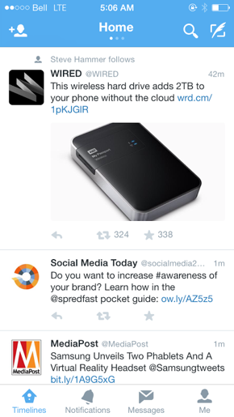In our everyday lives we used many different applications, I started to look into how these applications are structured and designed. It became apparent straightaway that all the application uses the same simplistic log in page. This means to use the application you would either have to register or log into an account. I believe this would be the best way to use the IWIC application, you would not have to be a Hot-Desk user of the IWIC but merely have an account so that we could send notification and information, rather than having to keep checking on the app and log in as guest. Applications most of us use every day – Facebook, Twitter, LinkedIn and Snapchat etc use the same simplistic log on page, which forces the user to register or log in thus means that people will be familiar with the process. Moving away from the log in side of things, when you log into most apps you are shown a feed of information. I would suggest implementing this as a way of showing all news updates, information and how to sign up to hot-desking and booking event etc. You will also notice the bar at the bottom is where you could have buttons to the main pages.

## Summary of research – Most applications use the same structure, if we structure our applications in a similar way, the end user will have a familiar experience.

## Implication on the project – Structuring a News Feed can be difficult and will require more time than a simple page structure.